A

Report

On

WALL MAGAZINE 2022

Department of PHILOSOPHY

Rabindra Mahavidyalaya, champadanga,hooghly

Session: 2022-23

Theme: SWA-HETU-SATTAR PRATIFALAN

Venue: Department of PHILOSOPHY

Rabindra Mahavidyalaya, champadanga,

room no. 71

Date: 20th August ,2022

Organizer: Department of Philosophy

Objectives:

- Development of soft skills.

- Ability to grow presentation skills, engage in meaningful discussion to arrive at a shared understanding their oral work, combining information.

- Enhancing students’ intelligence.

- Building students’ confidence

- Dealing with critical and argumentative situation

summary

:
An Wall Magazine is organized by the Department of Philosophy on 20th August 2022.Two more programs were held on that day, freshers welcome and Farewell. The topic of Wall Magazine was “SWA-HETU-SATTAR-PRATIFALAN". First Dr. Atanu Das, Professor of Physical Education Department, inaugurated the wall magazine in the presence of professors and students. Students’ and professors from other departments were also present. The topic of wall magazine was presented in front of everyone by Amrita Dolui student of philosophy department. Teachers of other departments also gave speeches. Then everyone reaches room no 71 for the rest of the program. On that day a special performed a special Santali dance drama. It became the special attraction of that day. Along with some cultural events, such as recitals, dances, songs, speeches etc. are also held.
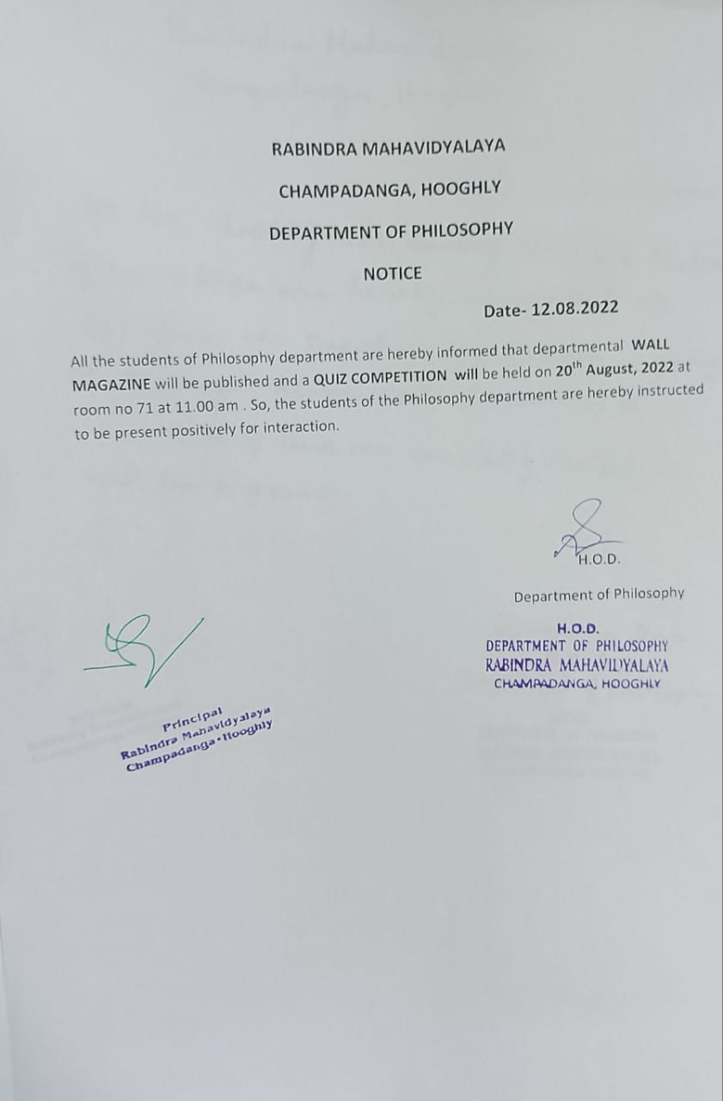

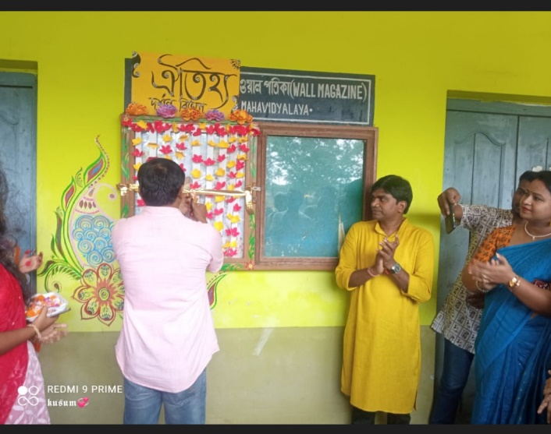 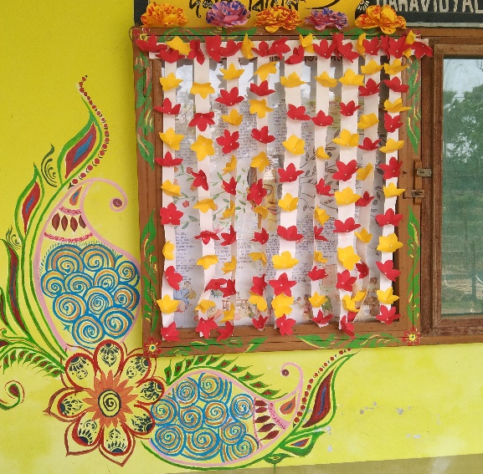Inauguration by Dr. Atanu Das(dept. physical education)

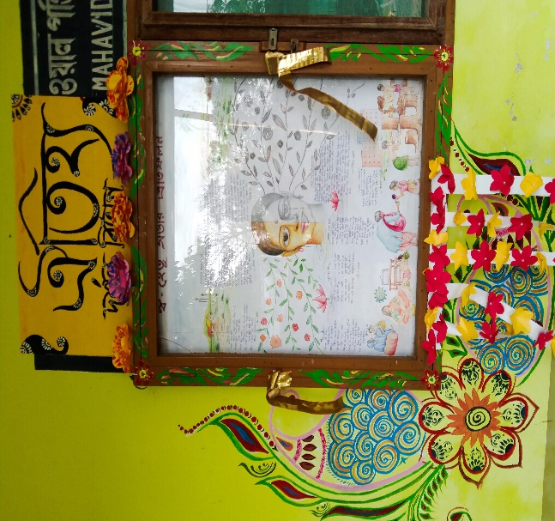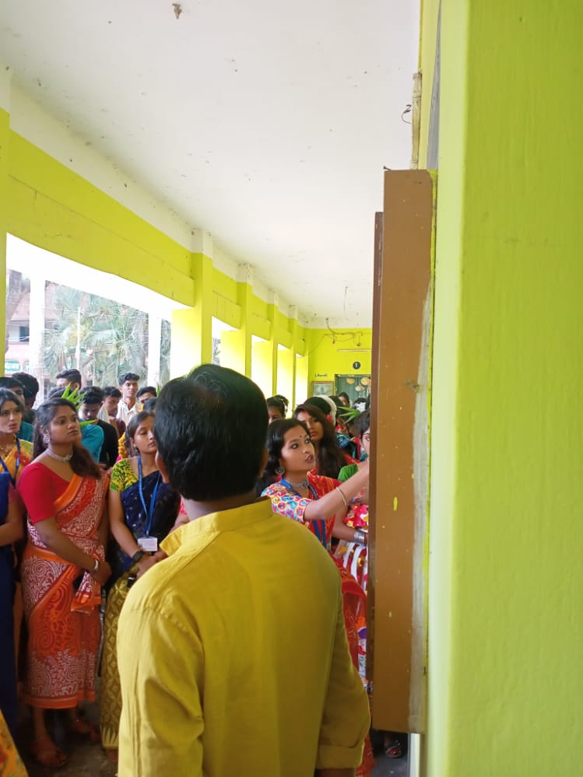
Topic present by student
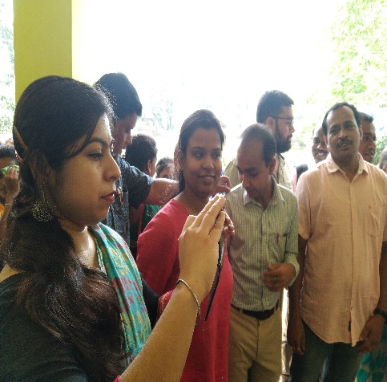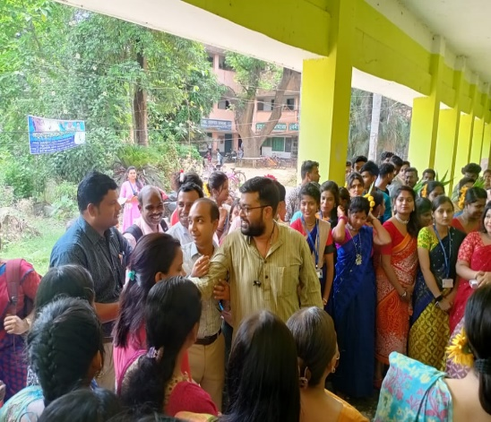
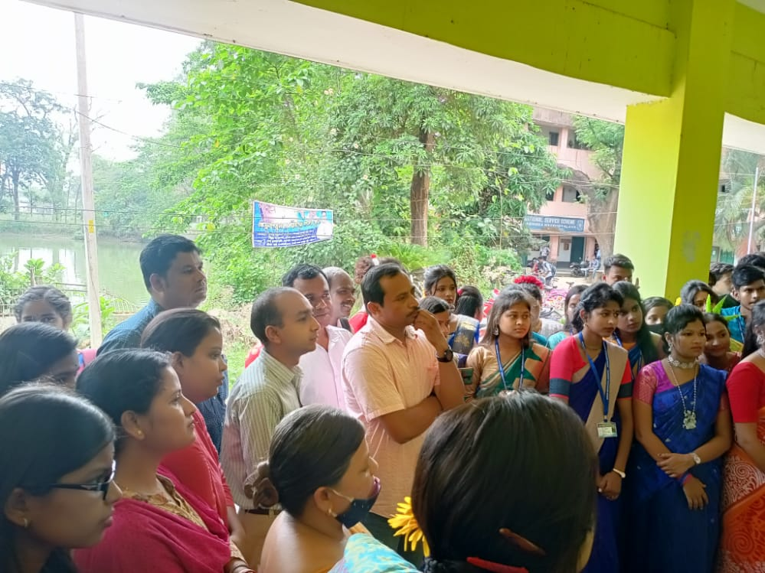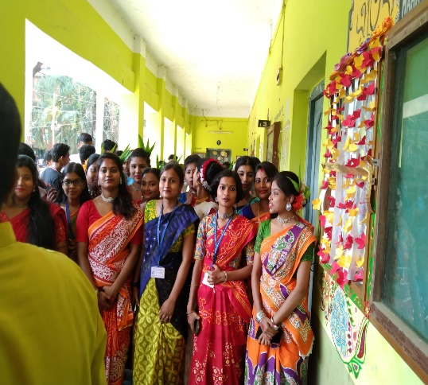
Other departmental teachers and our students
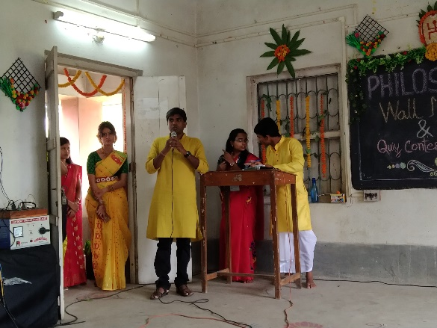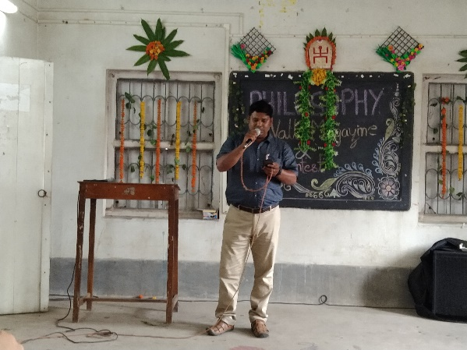
Speech by Departmental head performed by other departmental prof.

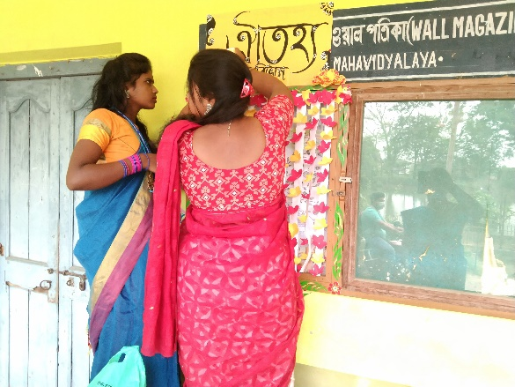
Decorate by students
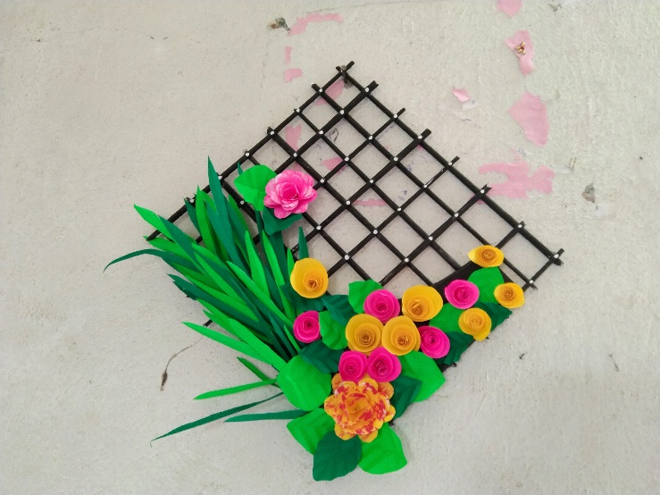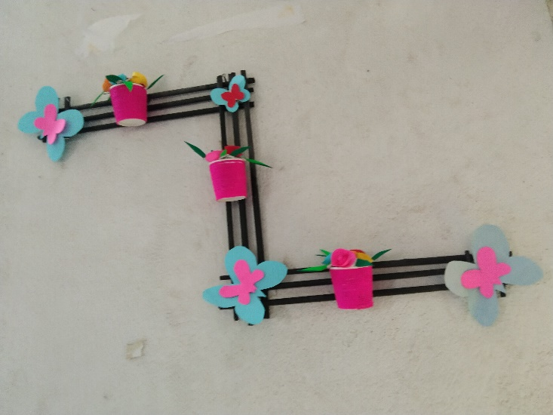
Decorative item made by our students

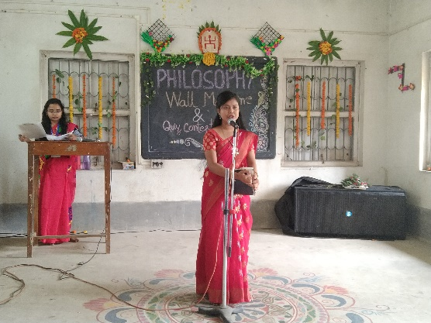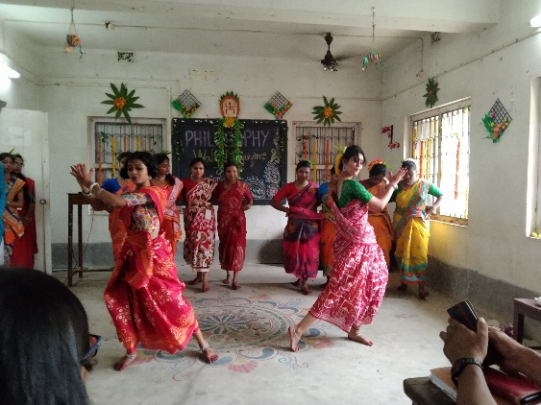
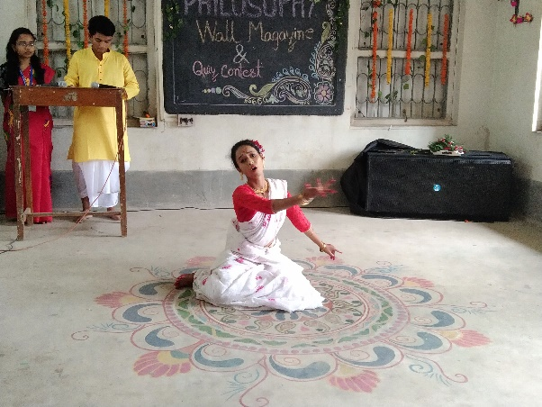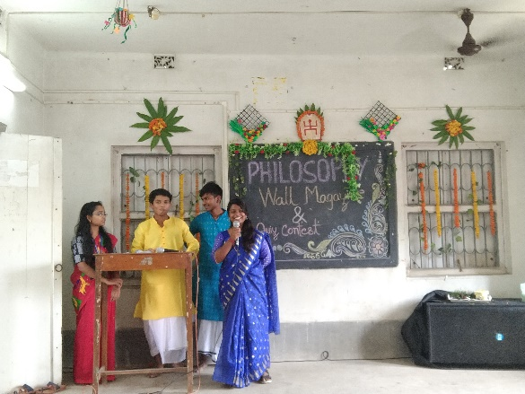
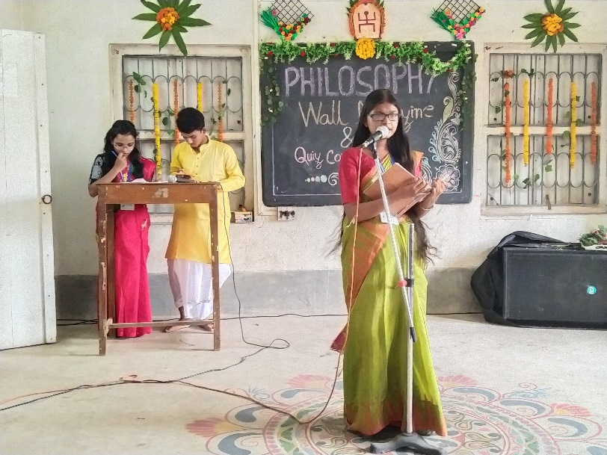
Different cultural programe

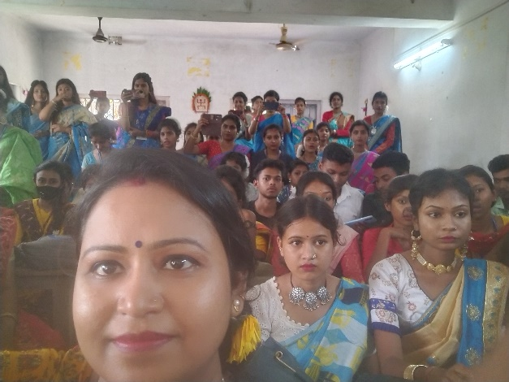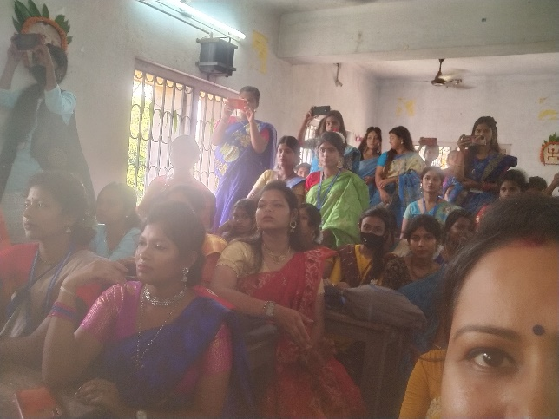
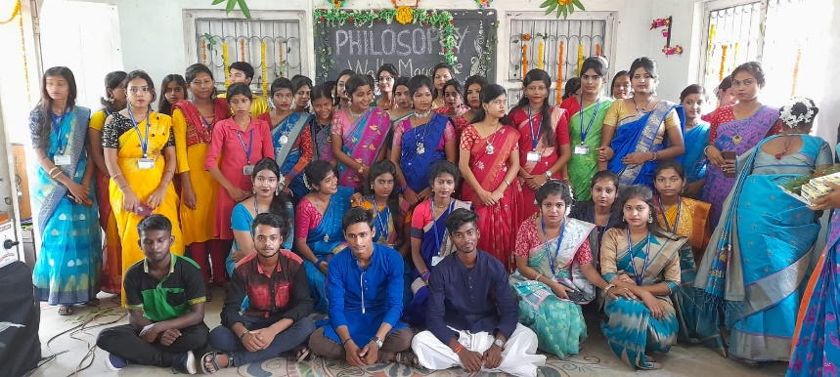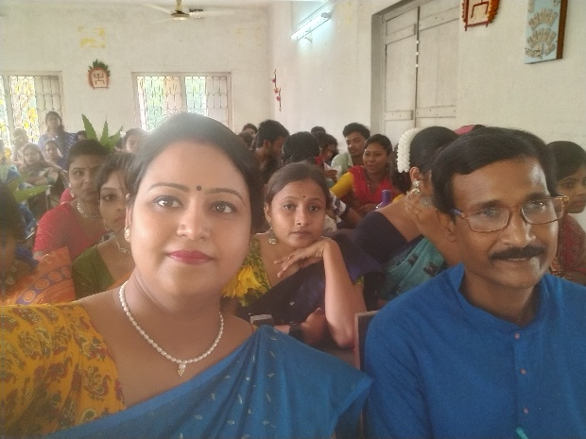
Audience

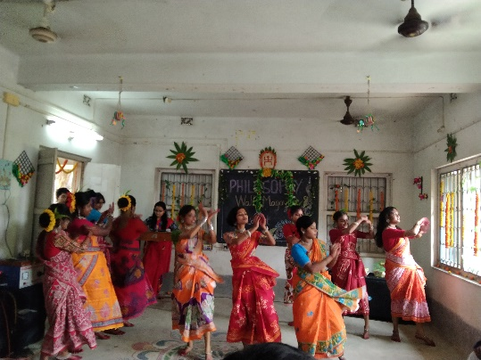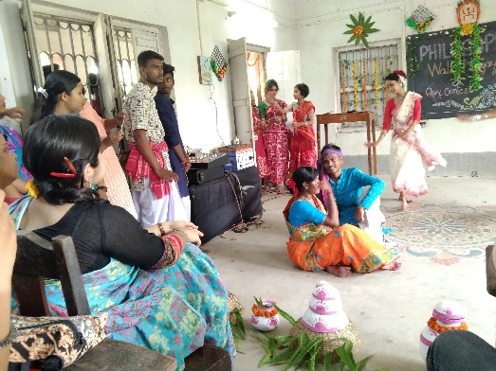
Dance drama performed by students
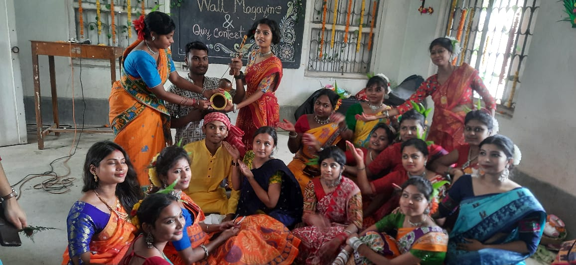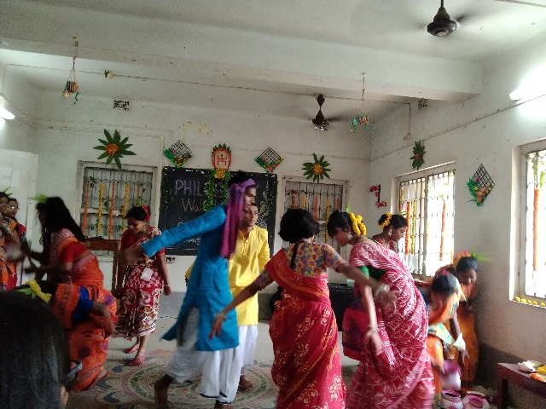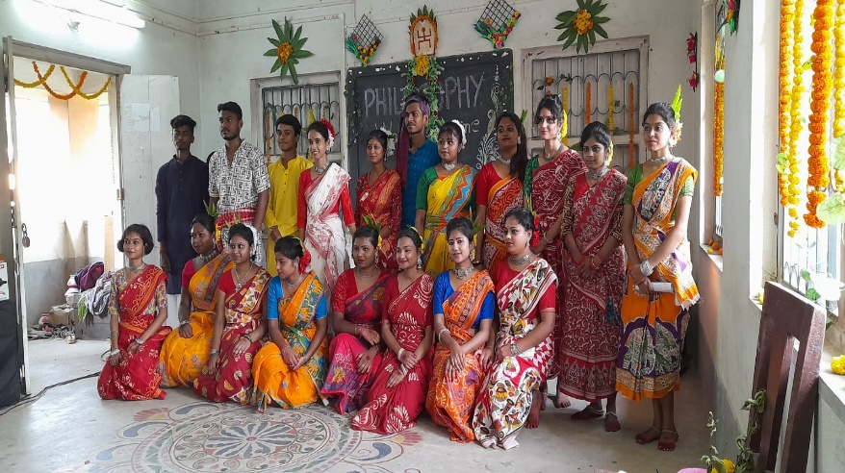
Dance drama team
Our perticipent: 70
Male:20
Female:50

Tentative programme schedule:
- Inaugural session: 12 noon to 12.15 p.m.
- Theme present to audience: 12:15 p.m. to 12.30 p.m.
- Other speech:12.30p.m. to 1.00p.m.
- Lunch break: 1.00 p.m. to 1:30 p.m.
- Cultural programme: 1:30 p.m. to 4:30 p.m.
Dance drama, singing,recitation,dance etc.

